**Real-Time Self-Adaptive Distributed Firewall System**

**Abstract:**  
This project presents a real-time, self-adaptive distributed firewall system designed to dynamically detect and respond to network anomalies across multiple endpoints. Leveraging Deep Packet Inspection (DPI) tools such as Zeek, Suricata, and Snort, the system identifies threats up to Layer 7 (L7) of the OSI model. Upon detection, the Central Policy Engine generates nftables rules using a trie-based structure for efficient pattern matching and rule deduplication. Rules are dispatched via WebSocket (preferred) or REST API (fallback). Logs are streamed from endpoints to the central server using WebSockets, with periodic cronjob-based REST pings to ensure availability. The entire framework is built using Python and FastAPI, targeting Linux environments like Kali and Ubuntu.

**Tools and Technologies (T&T):**

| **Component** | **Technology/Tool** | **Purpose** |
| --- | --- | --- |
| Programming Language | Python | Core development |
| Framework | FastAPI | REST & WebSocket API framework |
| Firewall Enforcement | nftables | Rule enforcement at endpoint level |
| Pattern Matching | Custom Trie (Python) | Fast rule lookup and duplicate prevention |
| Detection Engines | Zeek, Suricata, Snort | L7 network anomaly detection |
| DPI Helper | PolarProxy | Decrypt HTTPS for DPI tools |
| Packet Capture | Scapy | Additional anomaly detection |
| Communication | REST + WebSockets | Controller ↔ Agents for rules & logs |
| OS | Kali Linux, Ubuntu | Test environment OS |

**Functional Requirements:**

1. Real-time monitoring and alert generation using DPI tools.
2. Centralized rule generation using trie-based pattern matching.
3. Dispatch of firewall rules via WebSocket (primary) or REST (fallback).
4. Rule enforcement at agents using nftables.
5. Centralized log storage from all agents.
6. Rule ACKs via REST from agent to controller.
7. Continuous health check using cronjobs + REST ping.
8. Real-time WebSocket log streaming to controller.
9. Rule deduplication and tamper-evident logging.

**Non-Functional Requirements:**

1. Scalability to handle multiple endpoints.
2. High availability through fallback mechanisms.
3. Security through API key authentication.
4. Modularity for easy addition of new detection engines.
5. Efficient rule storage and retrieval via trie.
6. Extensibility for cloud logging and archival.
7. Minimal resource consumption on endpoints.
8. Operability on Debian-based Linux systems.

**Test Environment Setup:**

* OS: Kali Linux or Ubuntu
* Python 3.9+
* Tools to Install:
  + Zeek
  + Suricata
  + Scapy
  + nftables
  + PolarProxy
  + FastAPI + Uvicorn
  + Requests, PyYAML, Websockets

**Testbed Requirements:**

* **VM1 (Controller)**:
  + Runs central_engine (main.py)
  + Stores logs from agents
  + Generates and dispatches rules
  + Listens to alerts from agents
* **VM2, VM3, VM4 (Agents/Test Users):**
  + Run Zeek, Suricata, or Snort
  + Run agent FastAPI server (REST & WS)
  + Receive rules from controller and apply via nftables
  + Send alerts/logs to controller via WebSocket/REST
* **Network Configuration:**
  + Controller and agents on same subnet or reachable via IP
  + WebSocket and REST ports opened and forwarded correctly
* **Startup:**
  + A single script or command should setup dependencies
  + Agents should auto-start monitoring and connection services

**Network Topology for Real-Time Self-Adaptive Distributed Firewall System**

| **Component** | **Hostname** | **IP Address** | **Services/Modules** | **Communication Role** |
| --- | --- | --- | --- | --- |
| Central Policy Engine | VM1 | 192.168.56.10 | - Dispatcher (WebSocket + REST Push) - Zeek/Suricata Alert Receiver - Central Log Collector | - Sends rules to agents - Receives alerts & logs |
| Agent Endpoint | VM2 | 192.168.56.11 | - Zeek/Suricata - nftables Agent - WS & REST Server | - Sends logs and alerts - Receives rules |
| Agent Endpoint | VM3 | 192.168.56.12 | - Zeek/Suricata - nftables Agent - WS & REST Server | - Sends logs and alerts - Receives rules |
| Agent Endpoint | VM4 | 192.168.56.13 | - Zeek/Suricata - nftables Agent - WS & REST Server | - Sends logs and alerts - Receives rules |

**Communication Summary**

* → **WebSocket (VM1 ➔ VM2-4)**: Preferred real-time rule push from controller to agents
* ⟳ **REST Fallback (VM1 ➔ VM2-4)**: Rule push and acknowledgment in case WebSocket fails
* ⤴ **Log Streaming (VM2-4 ➔ VM1)**: Logs are streamed to VM1 over WebSocket
* ⏱ **Health Cronjobs (VM1 ➔ VM2-4)**: Periodic REST pings to verify endpoint availability or re-establish WS

**Testbed Deployment Notes**

* All machines reside in the **192.168.56.0/24** internal network
* WebSocket and REST services are exposed on separate ports per agent
* Each agent starts Zeek/Suricata locally to monitor traffic
* Centralized logging and rule dispatch are fully automated from VM1

Activity Diagram

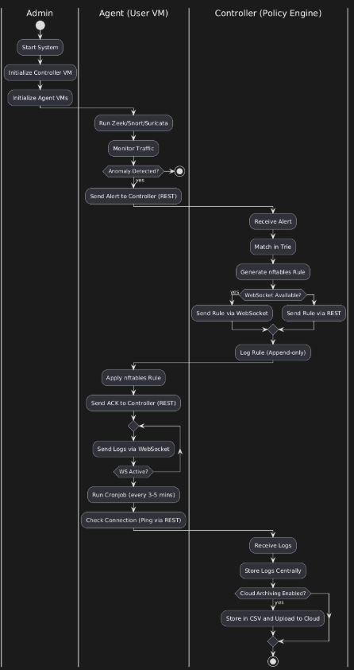

Sequence Diagram

